# Homepage

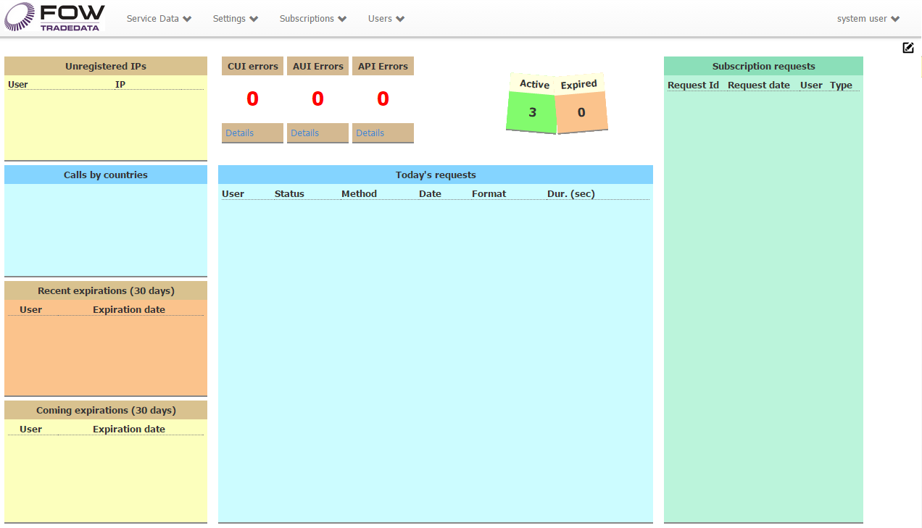

**Unregistered IPs**: When someone attempts to call a service method from the IP that is not yet allowed, the IP will be recorded and shown in this informer.

**Calls by countries**:Juststatistics.

**Recent expirations (30 days)**: List of the users whose accounts had expired during the last 30 days.

**Coming expirations (30 days)**: List of the users whose accounts will expire within next 30 days.

**CUI Errors**: **C**ustomer **UI** – number of TODAY’s errors occurred on customer site, when click on Details, you will see ALL errors logged for the site.

**AUI Errors**: Administrative UI – same for administrative site.

**API Errors**: Same for the TradeData Service.

**Active**: Number of active users.

**Expired**: Number of expired users.

**Today’s requests**: List of requests to the service, including search requests on customer site (currently no limits for number of records, but can be changed in the stored procedure)

**Subscription requests**: List of requests from customer site to add or remove one or more packages. You can click on the request ID to open the Subscription Request page and approve/decline request. See the Subscription Request chapter for details.

# Working with grid

1. Look & feel

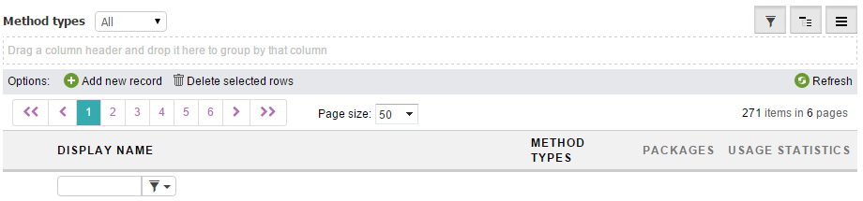

Grid allows to sort, group and filter records.  
Not all columns allow doing that, if the column is a result of transformation or data formatting, the filters are not available, it is also not allowed to use sorting and grouping.

For cleaner look and feel, you can hide some of the options, this is a minimal set of controls:

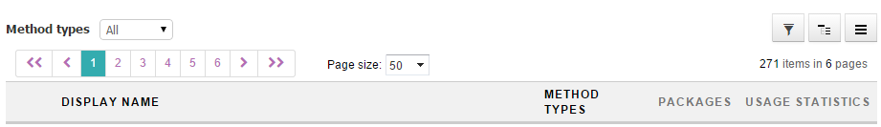

The pager appears automatically when necessary.

 Filter button, shows/hides the column.

 Group button, shows/hides the grid’s group panel.

 Command button, shows/hides the command panel, which contains Add, Delete, Refresh buttons.

The state of these three buttons and thus the state of grid panels is kept in cookies for each page separately, so next time you open the page, you will find it in the pretty same way you’ve left it.   
The page position is not kept.

2. Delete many rows

Click on row to select it, use may use Ctrl and Shift to select several rows or just press the left mouse button and move a mouse, then release the button.

You can now delete all selected rows.

# Companies

When adding company, you can choose the country.  
Also company has a list of IPs and each IP its own country.  
The IP’s country is determined automatically via the lookup service, so even the company’s country is set to particular value, the IP’s country may be different.

# IPs list

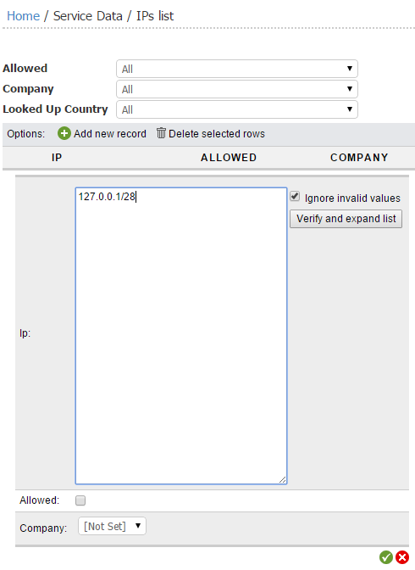Several IPs can be added at a time.  
You can add a list of IPs or use a CIDR notation as on screenshot.  
  
To see the final list of IPs that is ready to be saved, use the “Verify and Expand list” button. If “Ignore invalid values” is checked, all text that is not an IP will be removed, otherwise it will be marked as error, and you will be able to edit it:  
  
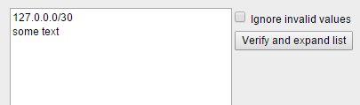

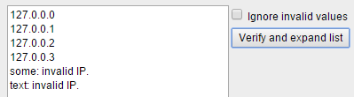

Since IP cannot contain a whitespace, it is treated as a divider.

It is also valid to use whitespace, comma, semicolon, new line.  
Duplicates will be removed.

|  |  |  |
| --- | --- | --- |
|  | -> |  |

You can do all these changes in both edit and insert modes.  
  
When you insert/update IP the lookup service will be started to determine the country the IP belongs to.  
This is an asynchronous operation, which depends on outer service, so the country may be updated a bit later after you have saved your changes.  
  
The IP country is also verified each time user calls one of the service methods, but the lookup is performed only if country field is empty in the database.   
  
If for some reason you need to update the country, it can be done in edit mode.

# Methods

There are three types of methods.

**1. Virtual**, it represents the alias for some interaction with the service, which does not really have a corresponding stored procedure, for the moment the only virtual method is Get By Symbol, which stands for search.

**2. Informers**, these methods are used to fill informers with data.  
  
**3. Data**, the methods, which are the subject of trading.  
  
Methods are the aliases for stored procedures and cannot have an arbitrary Name.  
Usually the name like GetCFIUnderlyingAsset will be translated to something like spTDAppSelectCFIUnderlyingAsset.

The Display Name is free for changes.

Methods cannot be included into subscription by themselves, to do this the Package should be created.

Permissions